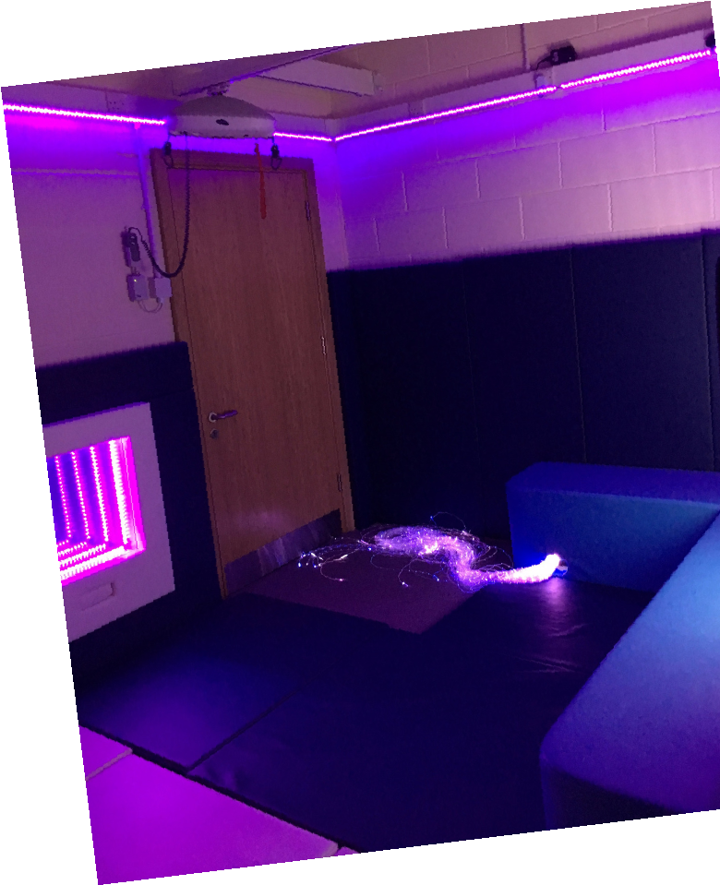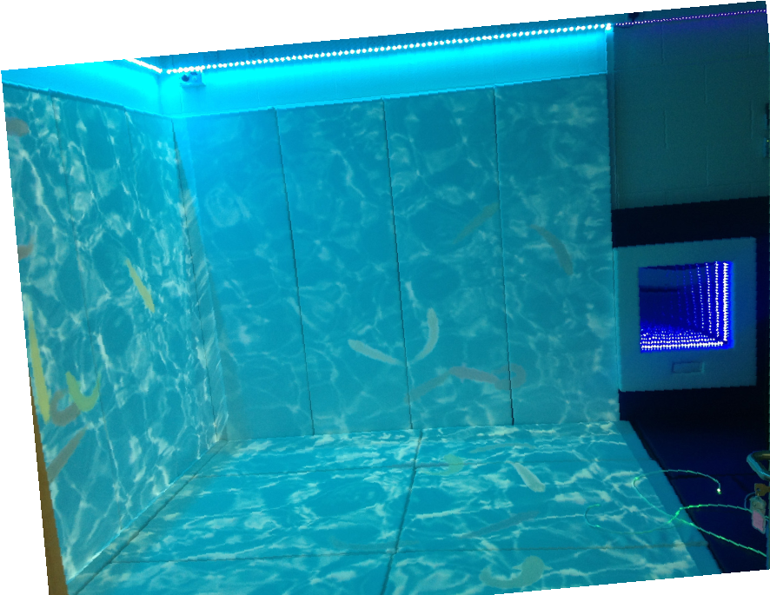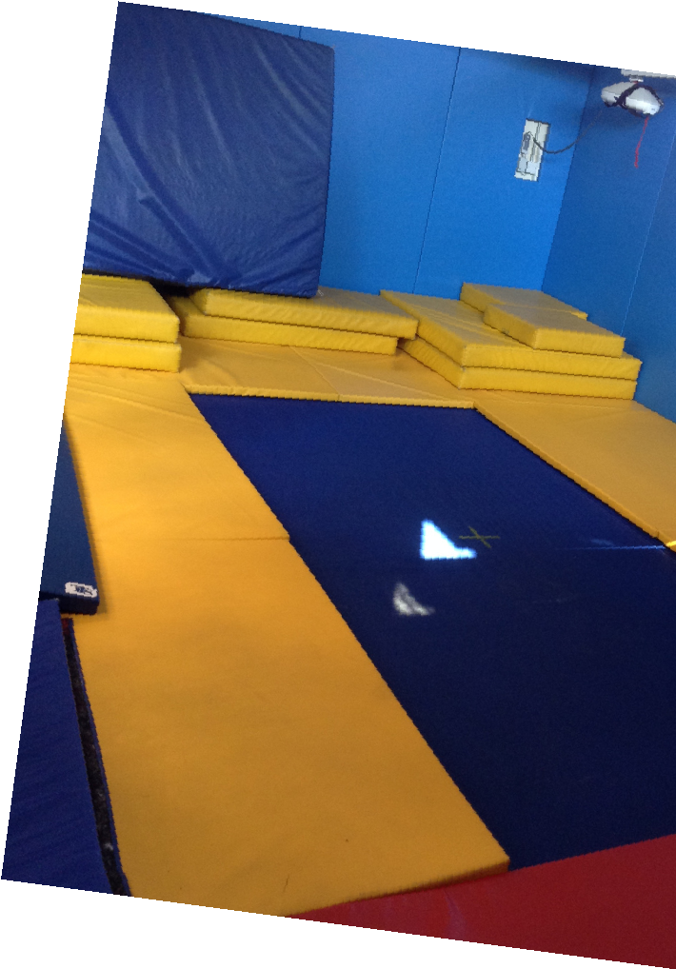

PLAY, LEARN AND

GROW TOGETHER!

Our

stay and play session aimed at

families with children with

additional needs from 0-4years

old.

Friday = 12.30pm – 2.30pm (term time only)

at Autism Inclusive Centre, Bramhall Road, Crewe, CW2 8PS

Meet other families

Messy and soft play

Sensory Room

oom

Sensory explore

Talk with other professionals.

Many more…...

We offer:

Booking is required so please either

phone or email

farida.begum@springfield.cheshire.sch.uk

tel: 01270

691900